Wreck of the Old 97
G C
Oh, they gave him his orders in Monroe, Virginia, saying,
G D
"Steve, you’re way behind time
G C
This is not 38, this is 0ld 97
G D G
You must put her into Spencer on time".

Then he turned around and said to his black greasy fireman
Shovel on a little more coal
And when we cross that White Oak Mountain
Watch old 97 roll

But it's a mighty rough road from Lynchburg to Danville
And from Lima it's on a three mile grade
It was on that grade that he lost his air brakes
See what a jump he made

He was goin' down the grade makin' 90 miles an hour
When his whistle broke into a scream
He was found in the wreck with his hand on the throttle
A scalded to death by the steam

Then the telegram come to Washington station
and this is how it read
Oh that brave engineer that run Old 97
He's a layin' in old Danville dead

So now all you ladies you better take a warnin'
From this time on and learn
Never speak harsh words to your true lovin' husband
He may leave you and never return
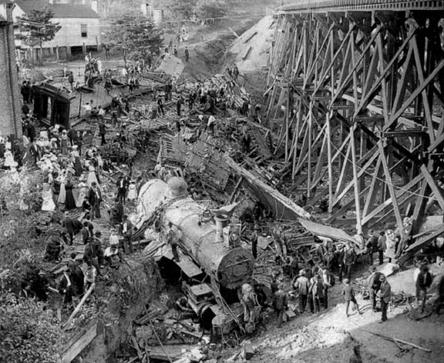

Old 97 was a Southern Railway train officially known as the Fast Mail. The train started its career on December, 1902, close to two years after Casey Jones's death. It ran from Washington DC to Atlanta, Georgia. On September 27, 1903 while en route from Monroe, Virginia, to Spencer, North Carolina, the train derailed at Stillhouse Trestle near Danville, Virginia. The wreck inspired a famous railroad ballad, which was the focus of a convoluted copyright lawsuit but became seminal in the genre of country music. (Country music’s first 1,000,000+ seller).

http://en.wikipedia.org/wiki/Wreck_of_the_Old_97

